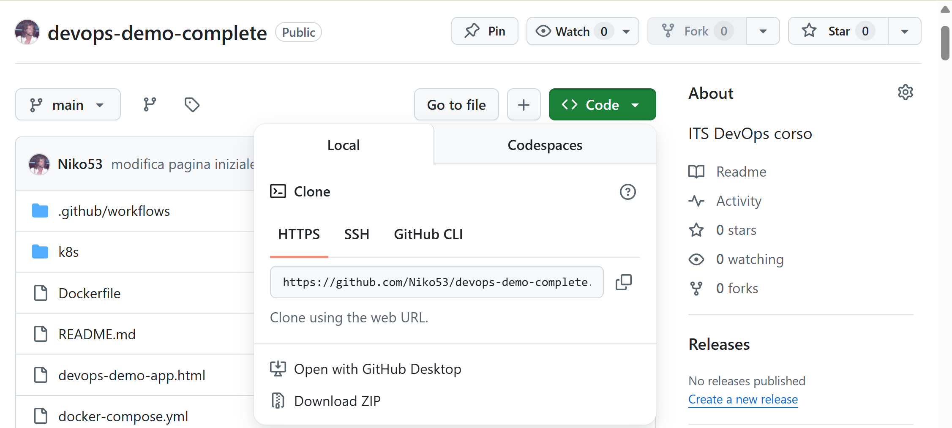

https://github.com/Niko53/devops-demo-complete.git

